**Facial Emotion Analysis using Computer Vision.**

Objective: To classify the emotion of a person whether it is Neutral, Happy, Angry, Fear, Disgusted, Sad, or surprised.

Goal: The goal of this task is to have a good knowledge of how computer vision can help in real-time scenarios. A good hands-on practice and exposure to a field like Deep Learning and Computer Vision.

Steps Followed:

Step 1: Collect images for training, validation, and testing. I used 28,000 images.

Step 2: Pre-process the images. Keep clean and clear images.

Step 3: Train the CNN model. Using 2 layers. More the layers, the more the complex Neural Network will become.

Step 4: Test the model by passing a video.

Step 5: Test the model by using a webcam.

Flow-Chart:

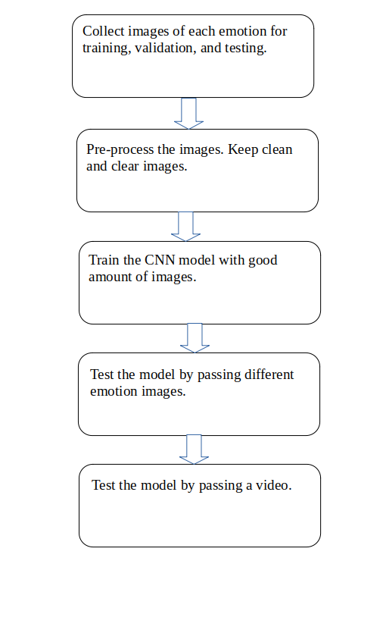

Use-Cases of Emotion Detection Model:

> Diagnosis Depression.

> Check Employee Stress.

> Student reaction in classes.

>Online/live gaming experience.

Output Images:

Using Webcam:

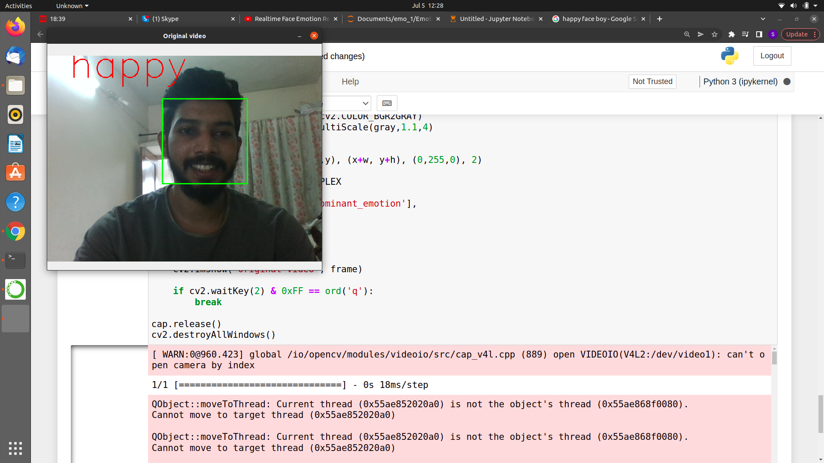

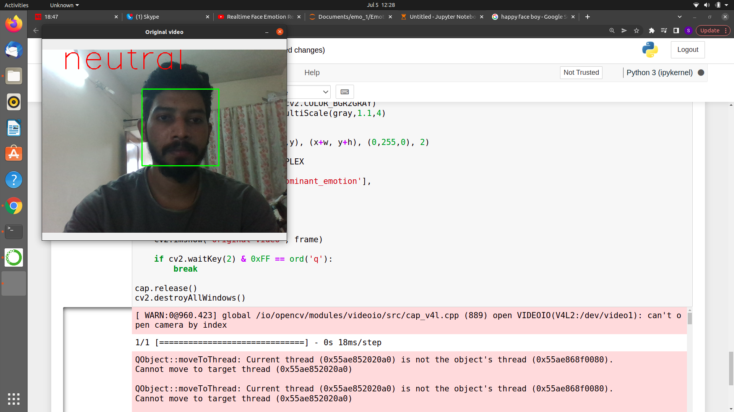

Using Video:

https://drive.google.com/drive/folders/11dpxbE5bhMc3SxA0gVCF8Tp6aZmxvGHY